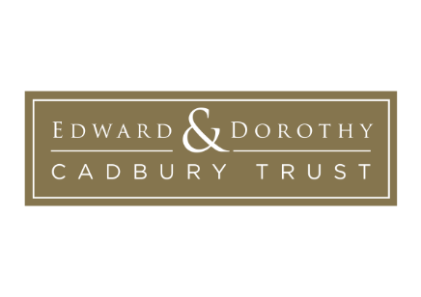 | (REF: unique reference no.  to be completed by E&DCT)

OUTCOME REPORT FORM

Organisation: Registered charity no:

Amount of grant: Date grant awarded:

Purpose for which the grant was given:

This form is for you to tell us about how the grant your organisation received from the Edward and Dorothy Cadbury Trust (E&DCT) has been used, how the project has gone and the impact it has made. Please answer all questions that are relevant to you.

1. What were the key aims of your project?

2. What were the main activities that you undertook to achieve these aims?

3. Please tell us about the people who took part in your project and how many benefitted from it?

4. What do you feel has been achieved by your project?

5. Do you intend to develop the project and, if so, how?

6. How did you hear about the Edward and Dorothy Cadbury Trust?

7. Has the grant from E&DCT helped your charity get funding from other sources?

8. Are there ways in which you feel that E&DCT could improve the grant application process?

Name of organisation: ………………………………………………………

Name of person completing the form: ………………………………………………………

Contact details:

Date:

When returning the completed form to us, please also send a set of approved accounts for the financial year in which you received the grant. If these are not yet available, please forward them to us as soon as possible. Thank you

Return by email to: e-dcadburytrust@btconnect.com or by post to the address given below.

N.B. The information provided in this Report will be processed and stored in accordance with the Edward and Dorothy Cadbury Trust’s Privacy Policy available at www.e-dcadburytrust.org.uk

THE EDWARD AND DOROTHY CADBURY TRUST
Registered Charity No. 1107327 Company Limited by Guarantee No: 5300961
Registered Office: Rokesley, University of Birmingham Selly Oak, Bristol Road, Selly Oak, Birmingham B29 6QF

